**Safeguarding the Affordability of Public Housing in Singapore**

*Singapore Management University*

# Introduction

Singapore’s HDB was first established in the 1960s to sustain rapid economic growth through providing affordable public housing. After 60 years it has ironically become a source of intensified wealth inequality widening across generations that has become an increasing source of tension both politically and economically (Stevens, 2024).

As the housing market liberalised in the 1990s, and economic conditions improved, private investment soared in popularity. Wealthy families who could afford condominiums choose to purchase large HDB flat(s) in prime locations and flip them after the initial 5-year lease for almost guaranteed profit (Rapacki, 2023), out-competing other aspiring homeowners and driving up prices. Build to Order (BTO) [A1] HDBs also have their price pegged to both rising land costs and a percentage of existing market value of ever expensive resale flats, contributing to ever-increasing flat prices for both resale and new BTO flats (Rapacki, 2023). The government has no easy solution to this problem, having to balance between maintaining the value of older flats for citizens looking to downsize for retirement whilst maintaining affordability for young homeowners of the next generation.

In essence, rising HDB prices are decreasing affordability of public housing for first-time buyers and retirees looking to downsize, with the government being unable to ensure affordability whilst preventing a devaluation of existing properties.

This project aims to develop a dashboard for primarily government and soft commercial use to visualise the various factors that contribute to the upward trend of HDB resale prices with historical trend data while analysing the distribution and accessibility of public facilities. Our main objectives are:

1. Visualise and identify the main factors that contribute to elevated HDB resale prices (Distance to MRT stations/ shopping malls /schools etc), and isolate long-term trends which drive up the price of flats whilst analysing the effect of policy changes.
2. Identify locations where public infrastructure is lacking, to locate areas with deficits in infrastructure that make these locations less appealing, so that they can be redeveloped to take buying pressure off prime locations.
3. Provide transparency to the opaque and complicated HDB resale market (See Section 2)

These findings will be used for future policy development coupled with planning and development of state land to cool the overheated HDB resale market and ensure affordable housing for the young Singaporeans and the elderly alike.

# Motivation

Up to 56% of Singaporeans in their 20s are concerned about home affordability citing a highly competitive real estate market with 38% of all Singaporeans expressing similar worries according to a survey done by OCBC (Jewel, 2023) With this predicament increasing, up to 66% of young Singaporeans aged 22 to 39 are turning to rent or shared housing simply because home ownership is out of reach, further supporting the gravity of the problem (J, 2022).

In our research we found several factors which were significant drivers contributing to the upward trending price of public housing:

1. BTO or Resale - There is a significant backlog of incomplete BTO flats due to the Covid-19 Pandemic, particularly in popular housing estates, which are oversubscribed by up to 6 times on average (Foo, 2021).[A1]
2. Proximity to amenities and public facilities - So-called “prime locations” are few and located in central regions nearby to multiple facilities including schools, MRT stations, shopping malls, and key transport nodes which can easily increase price by up to a factor of 2-3 times (Foo, 2021). Flats in these areas could be oversubscribed by up to 28 times above the average.[A2] [QJ3]

Despite the Urban Redevelopment Authority’s (URA) regular reviews in their Master Plan and development process, we find that their reports and approach places little weight on the economic factors of these developments on HDB flat pricing, including development cost, and existing market value. Current data analytics is primarily focused on the “How” of development, such as optimising wind flow between housing blocks, noise distribution and cooling (). Hence, the focus of our dashboard is on revealing patterns between factors in property appreciation to place greater weight on affordability as an evaluation point to inform future housing policies and urban planning initiatives for both flats and public infrastructure.

With this information in mind, we wish to design a tool for primary use by the HDB and URA.

Consumers tend to obtain information on property through resale websites such as PropertyGuru.com, or through real-estate agents. [A1] However, the information asymmetry between them and real estate agents means the latter have tremendous power in negotiating price, either in their client’s advantage or for personal profit (Tien Foo, 2024). Property websites are also unregulated and dummy or duplicate listings are often used to obscure the true value of flats, while drowning out cheaper options (Tien Foo, 2024). While not its original intention, we would like our visualisation dashboard to be accessible to consumers to provide an objective valuation of property free of commercial bias.

# Related Works

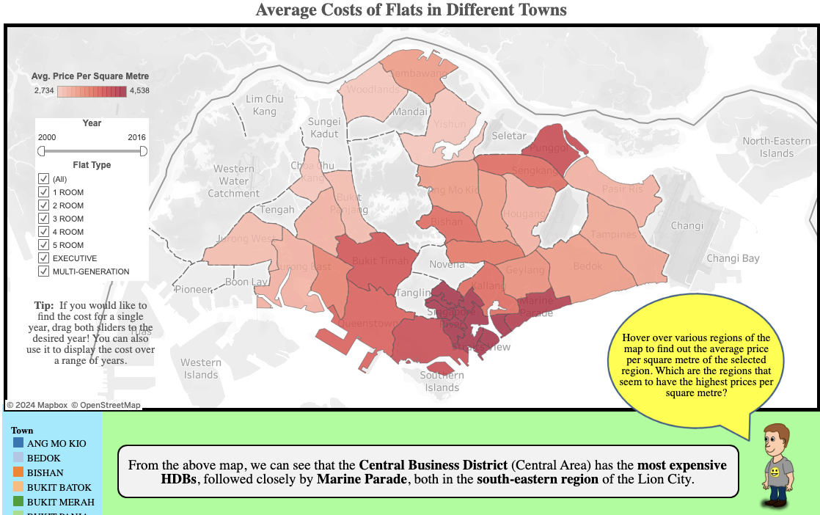

Figure 1: [HDB Prices Across Different Towns in Singapore Tableau workbook](https://public.tableau.com/views/HDBPricesAcrossDifferentTownsinSingapore/Viz?%3Aembed=y&%3AshowVizHome=no&%3Adisplay_count=y&%3Adisplay_static_image=y)

A team of Raffles Institution students created the interactive public workbook shown in Figure 1 that focuses on visualising HDB resale prices across various areas. It includes filtering options to explore data by area, flat type, and year. Our team was able to gather insight into a general uprising trend of increased prices and general flat cost relative to other towns.

However, this was done without attribution to any potential driving factors and lacked sufficient scope as an information dashboard suitable for government analysis and redevelopment projects. For example, factors such as proximity to schools or MRT stations, shopping areas etc were not included, and it does not offer further drill-down capabilities to individual addresses or a breakdown by flat-type.

We aim to adopt the interactivity and user-friendly assistance in interacting with the dashboard but incorporate more external data to investigate factors driving prices increases.

In the commercial space, HDB purchase/resale valuation tools have become available to the public, such as HDB’s RFL, 99.co’s HDB Value Tool, OhMyHome App and HDBEstimate. While these tools offer users smooth valuationand user-specific information into the opaque resale market, they are ultimately commercially driven and prone to the same drawbacks addressed in the last paragraph of section 2, justifying our angle toward an objective tool that simply informs consumers.

# Datasets

Our primary dataset centres on Singapore Home Resale Prices, which is updated annually from the Singapore government with accurate and representative data. Supplementary datasets will include other pertinent factors that we think may influence the prices of housing in an area, or over time, such as schools, shopping malls, and MRT stations, as well as general economic trends from 1990-2023.

## Static Datasets

**Singapore Home Resale Prices**

This dataset is provided and updated by the Singapore Government reflecting resale flat transactions, and features pertinent to the residence such as location, remaining lease, floor area, etc from 1990-2023 Due to the large number of datapoints ~800,000. We will be using the aggregate of average for most of our analysis for smoother dashboard performance.

**Shopping Malls**

A list of malls, their opening years and latitude longitude values obtained through geocoding, which we refer to as geospatial data.

**General Information of Schools**

This Dataset is provided by the Ministry of Education containing information about primary, secondary, and pre-university schools, including postal codes, official websites, and nearest MRT stations or bus services from March 2021 to March 2022.

**Stations**

A list of MRT stations, their years of construction, and geospatial data.

**Singapore’s Annual Employment Rate**

A dataset of Singapore’s annual employment rate of Singaporeans aged 25 to 64 from 1991- 2023.

**Singapore’s Annual Population Spread**

This Dataset contains multiple categories of people in a population from the 1950s to present day. Our primary fields of interest are Total population and Permanent Resident Population.

**Singapore’s Historical SORA**

The Singapore Overnight Rate Average (“SORA”) is the volume-weighted average rate of borrowing transactions in the unsecured overnight interbank SGD cash market in Singapore between 8am and 6.15pm daily. It is essentially Singapore’s interest rate published by the Monetary Authority of Singapore (“MAS”) which affects ease of access to loans for housing payments. In our case, we calculated the average by year, and matched this as an estimated interest rate for each row based on transaction year.

**Singapore’s Median Gross Monthly Income for Employed Residents**

This is the monthly median income sorted by year for employed Singaporeans, which will influence the purchasing power of those in the HDB resale markets.

# Tools and Resources

## Python

* + - **Pandas** for data processing, data manipulation, and exploratory data analysis like statistics, visualising distributions, handling missing data.
    - **scikit-learn** for building and evaluating machine learning models using functions of preprocessing, model selection, and supervised and unsupervised learning algorithms.
    - **Joblib** for saving and loading models and transformations for reuse. We used it to export and deploy trained models and feature scalers.
    - **SciPy**, a scientific computation library that extends NumPy’s calculation functions.
    - **Matplotlib** allows us to create static, animated, and/or interactive visualisations in Python.
    - **Streamlit** is an open-source Python library that simplifies the creation and sharing of custom web applications, especially for machine learning and data science projects.

## HTML

We used this basic scripting language frequently used by web browsers to render pages on the World Wide Web.

## JavaScript

A scripting language for creating dynamic and interactive web page content like dropdown menus, animations, dynamic background changes, and embedding of data visualisations and live updates, making websites more engaging. It is also used with Tableau Public API to embed our visualisations to a web page*.*

## Tableau

A powerful, user-friendly, and intuitive tool used for data visualisation and dashboard creation as it allows creation of a diverse array of graphs and maps. Application of this new tool for our team will pose a challenge as all of us have no experience with this tool beyond class experience.

# Tasks

## Conduct temporal and spatial analysis of resale flat prices

By examining trends in resale prices over time and by flat type, we can gain insights into the state of the housing market. Viewing the data from a government planner’s perspective, we analyse the distribution of prices by town, address, and flat type, along with flats sold by town relative to all of Singapore. Apart from assessing affordability, we aim to identify areas with deficits in public infrastructure and recommend targeted measures to gradually stabilise the resale market.

## Investigate drivers of upward HDB resale price trends

After some research and consultation, we zeroed in on factors likely to correlate with HDB resale prices:

* **Remaining Lease**

Known to influence resale prices, we assess the strength of this relationship and whether policy interventions on lease terms could moderate prices.

* **Floor Area (Square Metres)**

Another established driver, we aim to evaluate the strength of this relationship for planning of future flats.

* **Interest Rates**

Since interest rates impact the ability to make loans, it has an inverse co-variation relationship with resale price and we intend to examine the strength of this effect on resale prices as a potential regulatory measure.

* **Employment Rates**

Employment stability influences purchasing power and loan eligibility, indirectly affecting resale prices by increasing or reducing buyer demand. This factor offers insights into the predictability of resale prices.

* **Population Growth**

Demand due to limited land and a growing population is inevitable, underscoring the inevitable need for supply strategies to meet demand.

* **Storey Range**

An unexpected insight, higher floors appear to command higher prices, likely due to better air circulation, more privacy, less noise and pests, and better views. This could influence architectural or soundproofing adjustments in lower-level flats and suggest a need for architectural improvements to equalise within necessary means, access to aesthetic features of a flat include greenery and a good good view.

## Investigate public infrastructure adequacy and effect on resale prices

* **Proximity to MRT station**

Car ownership in Singapore is a luxury almost equally as expensive as a resale flat, hence the accessibility to MRT stations could drive up flat prices, especially in towns with poorer coverage, which suggests inadequate public transport coverage relative to another town where it matters less.

* **Shopping Mall Proximity**

Distance to malls affects convenience and access to recreation, highlighting the value of nearby integrated hubs, e.g. Thomson Road has integrated living spaces that act as suitable substitutes to impractical emplacement such as a new mall.

* **School Proximity**

Many resale flat buyers are usually couples who wish to circumvent the waiting time of a BTO flat to start a family. We believe school proximity is one consideration for such buyers.

* **Distance to CBD**

In our dataset, the CBD was Upper Cross Street, in-between Raffles Place and Outram Park MRT Station in Chinatown. The commute time to the CBD may be a key factor for buyers without cars, suggesting room for public transport improvements.

## Creating transparency in HDB resale pricing

While primarily intended for government use, our data was publicly available information, hence we feel there should be no segregation between government and consumer dashboards. To this end, the more complex government dashboard and consumer centric dashboard will allow users to explore resale prices based on both micro and macro criteria, bringing transparency to the complex resale market and levelling the information gap for consumers.

# Method

## Data Processing

**Format Change in Data Collection in 2012-2014**

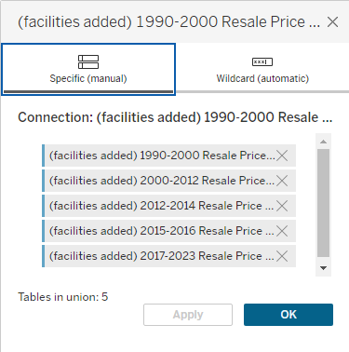

Figure 2: Making a union of the data

One notable challenge was a change in data collection methodology for resale transaction records in the year of 2012-2014 onwards where the columns were slightly renamed and rearranged.Thus, we standardised the column arrangement to the post 2014 method, and modified previous datasets 1990-2000, 2000-2012, and 2012-2014 to align with this standard using Excel. They were then merged into a union within Tableau, as in Figure 2. Additionally, there was a minor discrepancy in flat category where some CSVs used “MULTI-GENERATION” and some used “MULTI GENERATION” for flat type. This was fixed using a calculated field such that all CSVs use the former under the dimension “*Corrected Flat-Type*”.

**Related Supplemental Data**

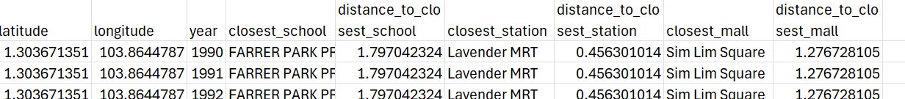

Figure 3: CSV output with closest amenities and distance

We lacked data on the proximity of schools, train stations, and malls to each HDB resale unit, which are believed to impact resale prices. To address this, we supplemented our dataset with the nearest amenities based on geographic coordinates and each facility's operational status in the unit’s resale year, using above mentioned data from official sources. The input CSVs are Schools, Stations, Malls, and Resale Listings.

Using Python, we calculate the straight line distances between each HDB resale unit and the nearest school, train station, and mall, taking into consideration the constraints of opening years. The Python file runs as follows:

1. Data Loading: Data is loaded from three CSV files into dictionaries for quick access, with the first entry's name and coordinates saved as "first_" variables.
2. Distance Calculation: For each resale unit, the closest amenity is set, and the straight-line distance is calculated using `geopy.distance.geodesic()`. The year constraint is applied, and the closest amenities are updated if a shorter distance is found. The closest three amenities and their distances are stored in a list.
3. Output: The "distances" list is written to an output CSV and merged with the original data as seen in Figure 3

Adding these proximity metrics as new features enabled us to analyse how access to amenities affects resale prices over time. The final HDB resale prices dataset includes additional columns for the nearest station, school, and mall, along with their respective distances.

**Non-related Supplemental Data**

Our original dataset lacked certain key micro and macroeconomic data that had potential to influence resale prices, hence we searched for and include the following:

* **Median Income for SG Residents 2001-2023**

Housing affordability is a central crux of our investigation, to this end, we decided to use a Housing Affordability Ratio (“HAR”) which is the resale price divided by median annual individual income as a calculated field. We chose individual income instead of household income as we did not want to make the assumption that a buyer is married. Resale flats are available to singles but not BTO flats which also have more subsidies that help with affordability issues. The HAR is a measure used by the Organisation for Economic Co-operation and Development (OECD) for measuring affordability of housing ().

To obtain income data, we used an estimation by taking the monthly employed median income by year and multiplied it by 12 to get the median annual income for each year from 2001-2023. This column was then connected using a left inner join to the HDB resale dataset, such that every entry had a median annual income based on the year of the flat purchase. This was used to calculate HAR.

* **Employment Rate of SG Residents 1991-2023**

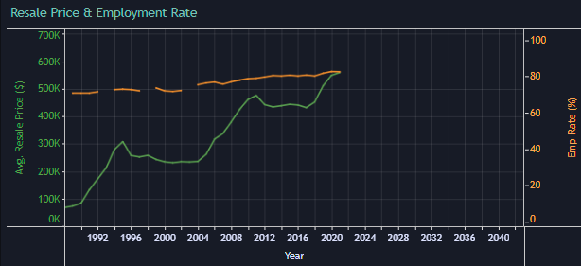

Figure 4: Missing employment data marked by gaps in the orange line

Similar to income, employment provides the ability to fund housing loans. Fluctuations in employment will directly affect the ability to engage in the resale market. We found employment data by year and used left inner join so each row now had an employment rate based on year of purchase. There are 4 NULL values where no employment data is available: 1990, 1995, 2000, and 2005. These were left in as such in Figure 4 as excluding them would lead to a misleading graph.

* **Singapore SORA 2005-2020**

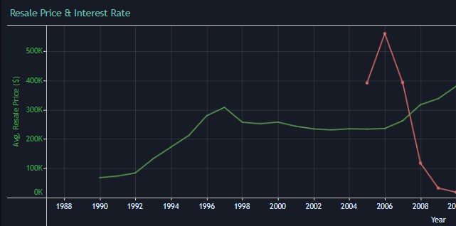

Figure 5: Interest rate data, in red, is absent prior to 2005

Singapore’s SORA or Singapore Overnight Rate Average is Singapore’s interest rate and directly determines the availability of housing loans to Singaporeans. We obtained the SORA average by year from 2005-2020 from MAS, and used a left inner join to connect to the hdb dataset, so each transaction has an estimated interest rate by year. There are some years 1990-2004 for which there are no interest rate values, hence we left the NULL values for interest rate so it can be seen alongside the resale price over-time as in Figure 5.

* **Population Spread of Singapore 1990-2024**

Demand with limited supply leading to price increases. We decide to focus solely on Singapore's total population over-time and its relationship with resale price. Hence we connected an annual census of the population using a left inner join by year to the HDB dataset, ensuring each row had data of that year's population. The permanent resident population was left out as while it did increase, it was very gradual relative to total population increase and comprises barely a tenth of Singapore’s population. We also lacked data to identify if a resale flat transaction was conducted by a citizen or permanent resident, making it infeasible to analyse the effect of permanent residents on resale price. For this reason, it was left out of the visualisations and further analysis.

## Tableau Dashboards

We envisioned a tool suitable for both government and consumer use in resale market analysis with price predictive capability. To this end, we came up with these dashboard designs after numerous iterations.

**DB1: Affordability Dashboard**

Housing Affordability Map Overlay:

* Resale Price Trend by Year
* Affordability Map by individual address
* Affordability changes by year

**DB2:** **Treemap Dashboard**

Distribution of flats sold by town relative to all of Singapore.

**DB3: Time Series Data Dashboard**

Spatial evolution of Resale price against economic factors:

* Interest rate
* Employment Rate
* Total Population

**DB4: Scatter Plots Dashboard 1**

We studied the explained variation of Resale price against various factors using scatterplots such as:

* Average Remaining Lease
* Average Floor Area Sqm
* Average CBD Distance (m)
* Average MRT Distance (m)
* Average Mall Distance (km)
* Average School Distance (km)

All distances are calculated as straight line distance.

**DB5: Storey Range Relationship Dashboard**

Resale price was plotted against the following:

* Storey Range
* Average Employment rate
* Average interest rate

**DB6: Toggling Dashboard for In-Depth Analysis**

Resale price against the closest:

* MRT Distance (m)
* School Distance (km)
* Mall Distance (km)

**DB7: Consumer Friendly Dashboard**

A map of all addresses of resale prices accumulated in Singapore from 1991-2023 for consumers to enter specific parameters, such as town, lease remaining and distance from cbd etc to search for available locations within their requirements.

**DB8: Average Resale Price by Town Dashboard**

Average resale price by town with filtering for flat-type and town for fine grain analysis. The plan for the dashboards in the website can be seen in the figure below:

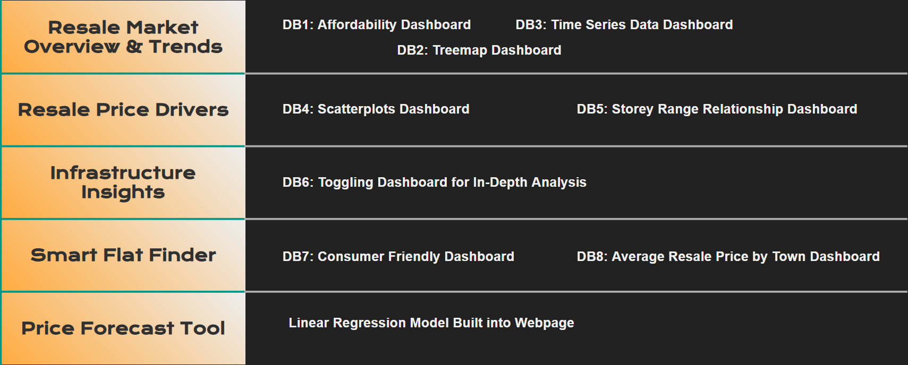

Figure 6: Distribution of dashboard among the web pages

**We followed these guidelines for our design:**

1. Data as a dimension or measure (eg: Continuous data such as resale price,
2. Key Story to be communicated to audience (Trend finding, distribution or relationships)
3. Iterative approach to choosing and refining visualisations to ensure a smooth flow
4. User ease of use and access

## Website Creation and Embedding

1. Import Streamlit library in a Python file
2. Use Streamlit to develop the front end with Streamlit’s functions
3. Import HTML from streamlit.component.v1 to introduce HTML elements and JavaScript code into Streamlit
4. Import Tableau CDN
5. Create Viz Containers for each dashboard
6. Refactor a Python script for machine learning and import it to a Streamlit page.
7. Create a form for a user to input parameters for predicting a resale HDBs price

# Visual Analysis Results & Discussions

## General Trends & Temporal Analysis

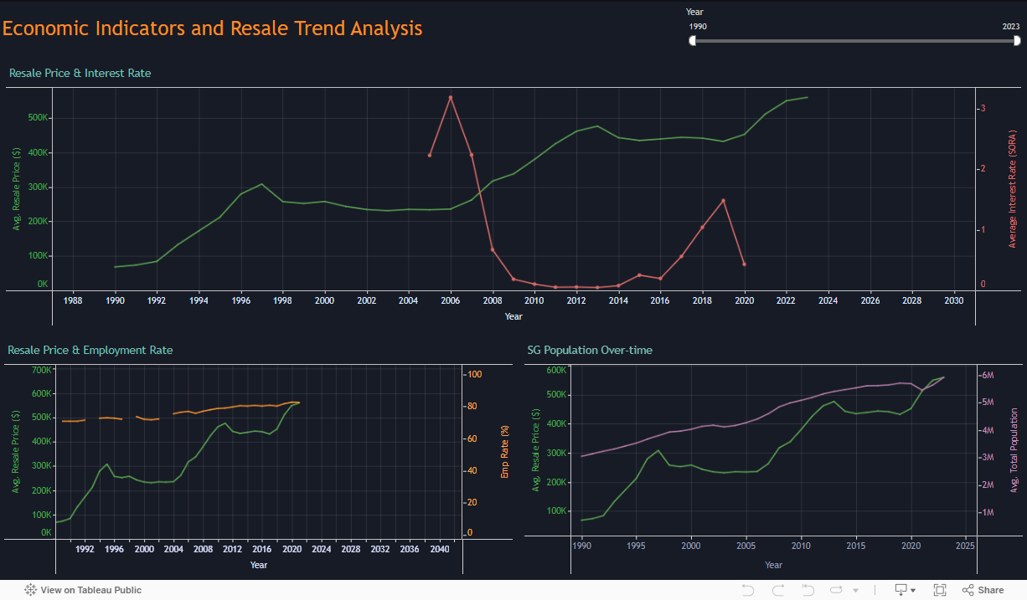

Figure 7: Economic Indicators analysis

A quick temporal analysis of the following economic indicators in Figure 7 suggests that Singapore’s total population has increased over-time with resale price, indicating a strong demand drive for the increased resale price. The permanent resident population can be seen in the tooltip, but no further analysis was conducted due to data limitations mentioned earlier. There is a strong inverse co-variation relationship between interest rate and resale price with the two having an almost opposing relationship making it a good predictor. However, the employment rate has remained fairly consistent with few fluctuations and cannot explain the large variations in resale price, hence we will not conduct further analysis for this metric.

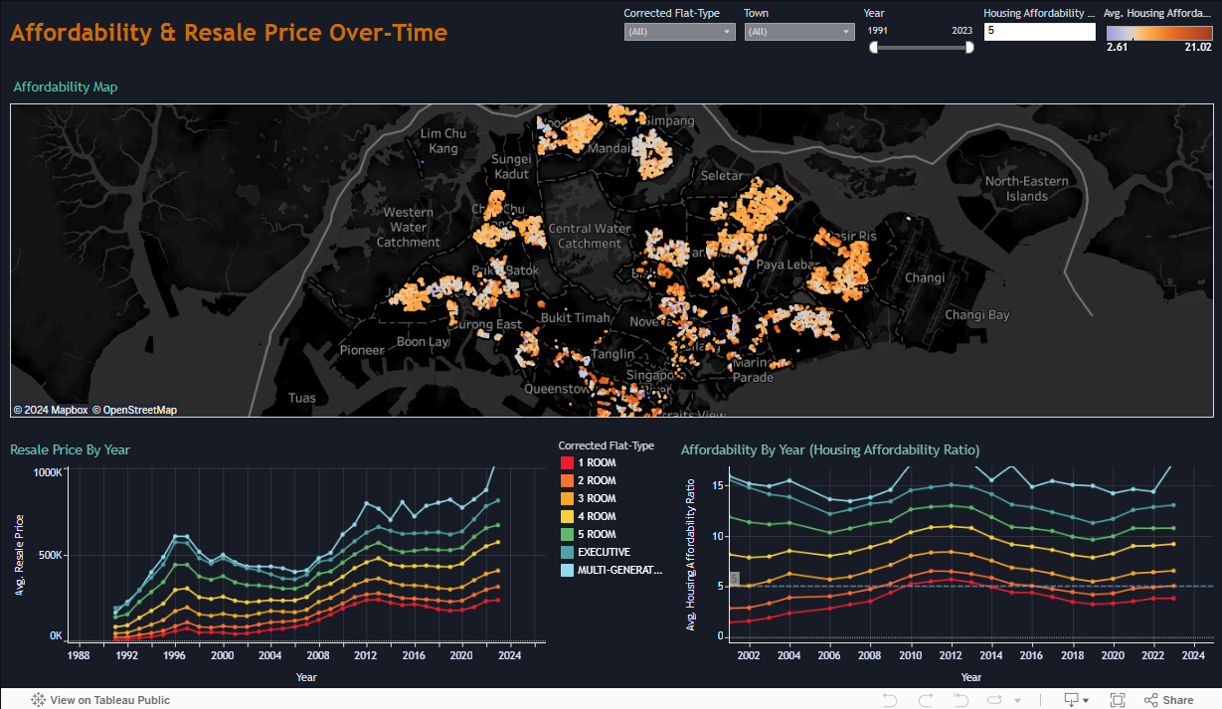

Figure 8: Affordability Dashboard

In our affordability dashboard, Figure 8, the lower left window indicates that resale flat prices have risen consistently across all flat types. However, we note the impact of inflation, and thus to assess affordability, we compare that to the median annual income levels across that period as well. An HAR > 5 is considered severely unaffordable (Chong, X. W., 2024). Based on the lower right graph of HAR over-time, we see that any flat type of 3 rooms and above consistently remains above the affordable line of 5. Furthermore, the Map indicates that this trend occurs irregardless of town, and almost all of them fall into the unaffordable category (as they appear in white or orange). This reinforces our initial research of ever-increasing unaffordability of housing despite increasing demand.

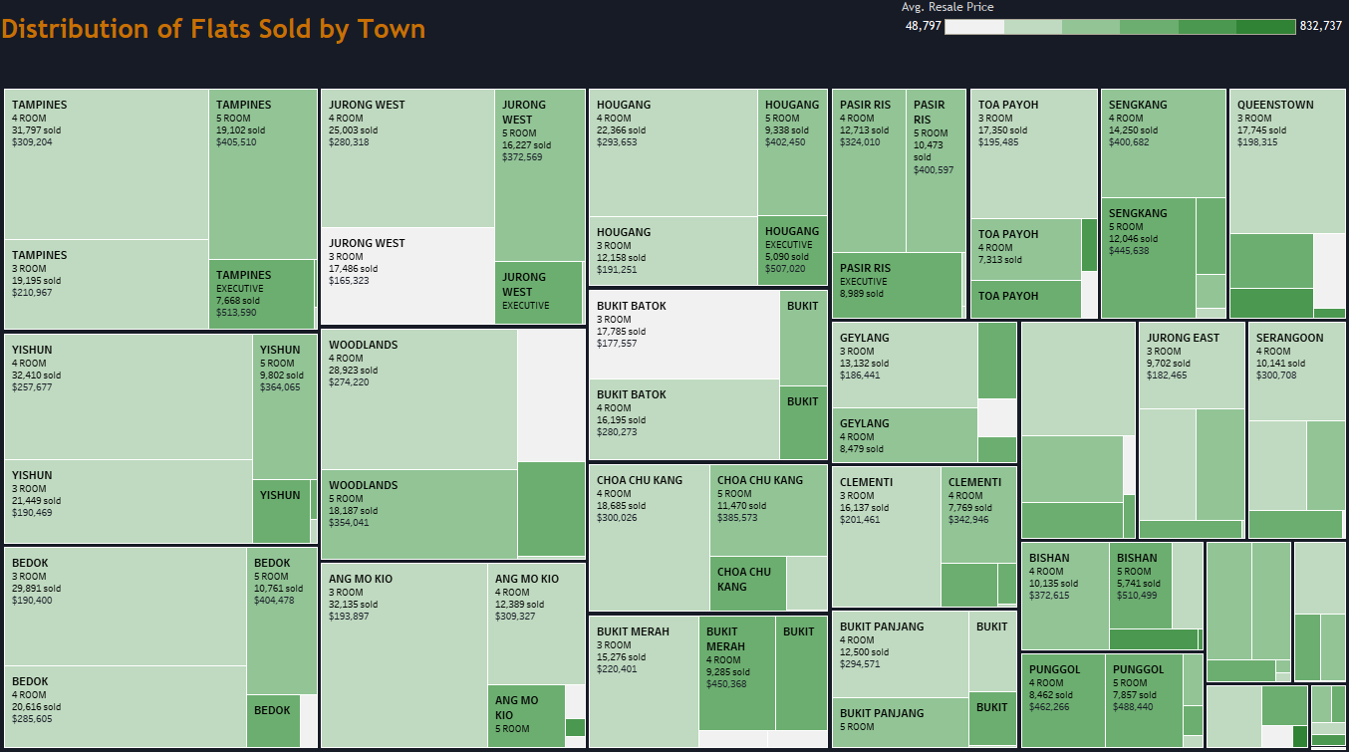

Figure 9: Treemap indicating distribution of flats sold by town since 1991

Analysis of Figure 9 suggests that the majority of resale flats being sold and bought are actually of the 3 and 4 room type, with an average flat price of just under SGD500,000, and not expensive flats which actually form a minority of all transactions.

Thus we recommend that the URA, HDB and policy makers should specifically target any improvements or changes for improving affordability to 3 and 4 room flats for the greatest impact in the market due to its prevalence in market transaction history.

We will now examine the factors that likely influence flat resale price, and examine how the government should target their changes in order to solve the unaffordability problem. Unfortunately, while interest rates have an inverse relationship with flat resale price, they are largely a by-product of exchange rate manipulation as part of Singapore’s economic policy and housing affordability falls secondary relative to Singapore’s export competitiveness. Hence we will analyse the remaining factors within the responsibilities of the HDB & URA.

## Driving Factors of Resale Price

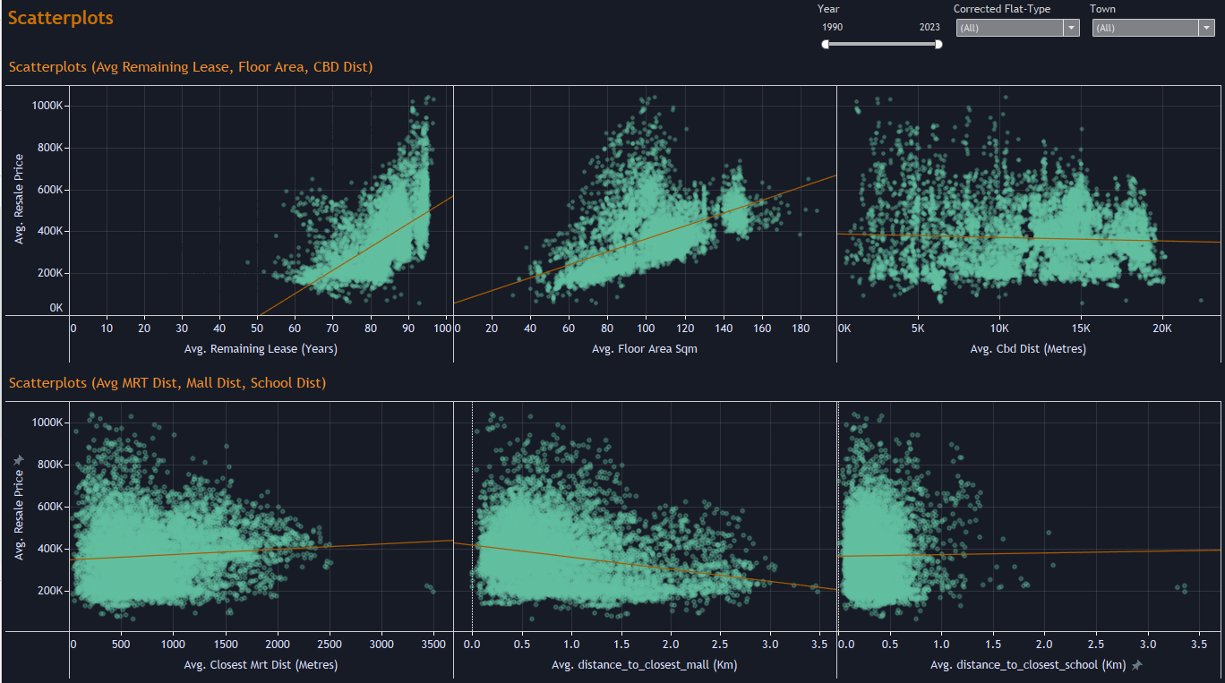

Figure 10: Scatterplot of driving factors

We conducted a basic correlation analysis on various factors driving resale price. Of the factors we analysed, the two most important factors included ‘Average Remaining Lease’, and ‘Average Floor Area Square Metre’ in the left side of the first row with both having a positive correlation to flat price, at 0.3459 and 0.272 respectively without controlling for other factors such as flat-type, suggesting this relationship could be stronger.

We think that policies or changes targeted at HDB Lease could be used to improve affordability but require many iterations of testing as part of sound government policy which we lack data or means to conduct. The floor square area is also a strong predictor but largely unchangeable after construction. Hence we do not have further recommendations.

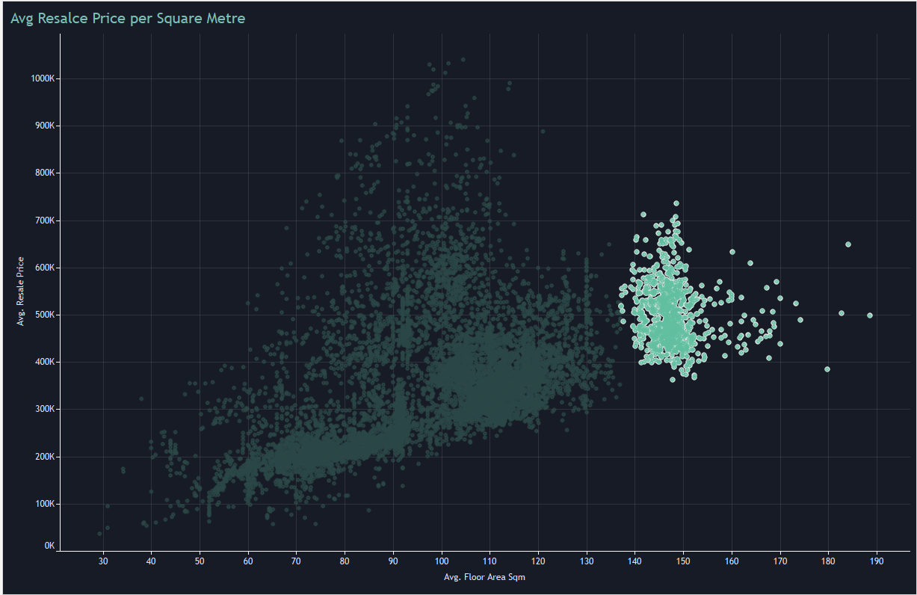

Figure 11: Unusual clusters of cheaper large flats

We noticed an unusual concentration of resale flat prices of some addresses in the 80 to 125 square metre range (3-4 room flat class) that surpassed even the resale prices of larger 140-190 square metre flats which is selected in Figure 11 (5 room and exec). This cluster consisted of multiple locations and were not unpopular estates, with the leases being more than 85 years. We theorise that the situation of tenants paying disproportionate amounts relative to their flats size could have arisen due to the information asymmetry between realtors and consumers, causing consumers to overpay simply because they were unaware of better deals. To this end, it reinforces the need for more objective valuation of housing for consumers to prevent exorbitant pricing of resale flats from becoming a norm, which our consumer dashboard aims to do.

Other factors such as CBD distance, MRT Distance, Distance, School Distance and Mall Distance showed no clear relationship and will require fixing some variables such as flat-type and town for analysis later in 8.3.

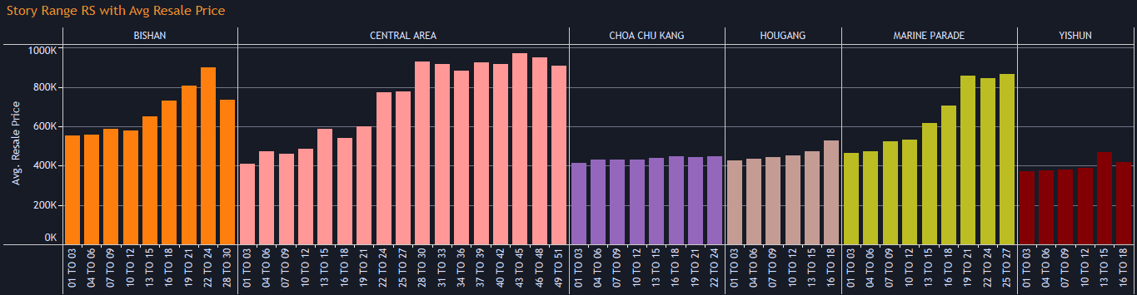

Figure 12: Storey Range Relationship with Resale Price (Shown few here only for simplicity)

## In our next figure, we found that across all towns and regardless of flat-type, any flat above the 15th floor tends to have an upward trending average resale price, which can easily double for similar types of flats at lower floors.

## Policy makers may want to conduct more research into this trend, and see what features higher flats offer, such as lower noise levels, better air circulation, fewer pest infestations and access to an above the treetops view. For example, mitigating these factors, such as reducing noise by soundproofing of lower levels, or conducting pest cleaning are cheaper alternatives to redevelopment that will make lower floors more appealing and reduce the price disparity with similar flats on higher floors.

## A long term solution will involve designing future residential estates that equalise access to these metrics.

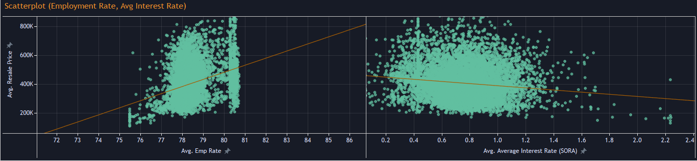

Figure 13: Employment Rates, left, and Interest rates, right

Surprisingly, plotting interest rate against resale price led to little correlation with R-squared = 0.069 which is contrary to the earlier temporal data where an inverse co-variation relationship was observed. However, since interest rate manipulation is unlikely, we did not pursue further analysis along this thread.

## Assessing adequacy of Public Infrastructure

We expected nearby public infrastructure to have an impact on housing prices across towns and thus conducted our subsequent analysis on this area.

Due to the large nature of complex interactions between data fields in our dataset such as town, flat-type and year which may obscure relationships, we decided to fix some variables to conduct an analysis of the effect of MRT distance, School distance and mall distance against Average resale price.

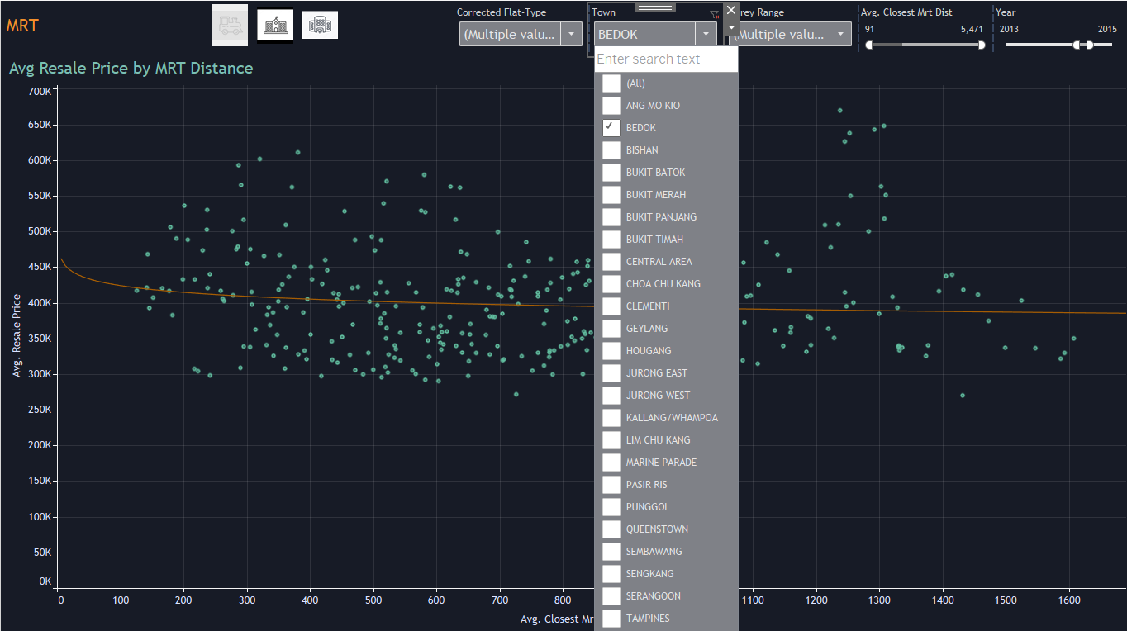

Figure 14: Analysis by town, fixing parameters

The parameters used for analysis were: Iterate through each town, analysing the R-squared for 3 and 4 room flats only of up to 15 stories for the year 2013-2015, based on the most fitting trend line (e.g. linear, logarithmic). This was used for all 3 domains of public infrastructure we are evaluating. The individual R-square per town were then noted down in a CSV file and plotted into a choropleth map. We chose 0.3 as the threshold for a significant R-squared and all legends use 0.3 as the centre value.

### MRT Proximity

Contrary to layman expectation, the relationship between MRT station proximity and resale prices was inconsistent and localised to specific towns instead.

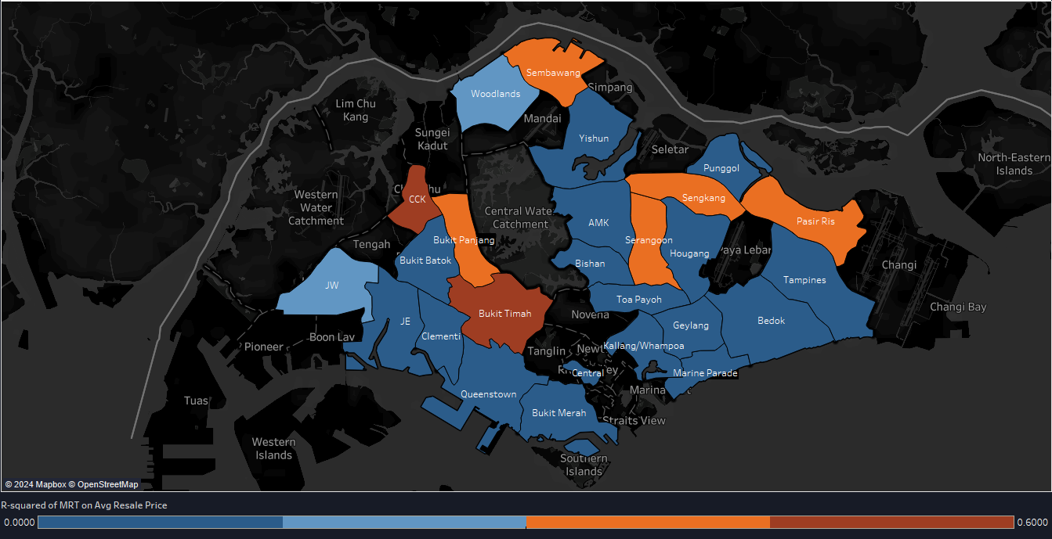

Figure 15: R-squared for MRT vs Resale Price (Center = 0.3)

From Figure 15, the towns that are most affected by MRT distance as a factor in resale prices are Bukit Timah, Choa Chu Kang, Serangoon, Sembawang, Bukit Panjang, Sengkang, and Pasir Ris.

This suggests that people are willing to pay a premium for the increased connectivity that MRTs bring in these areas, suggesting inaccessibility or inadequate MRT network coverage.

We recommend that in the short term, investigations be done into adequacy of existing bus services to the stations, and increase them especially during peak hours. In the long run, policy makers can focus on enhancing coverage either through expanding the MRT network or adopting a less costly approach such as the LRT in hopes of driving down prices in the area.

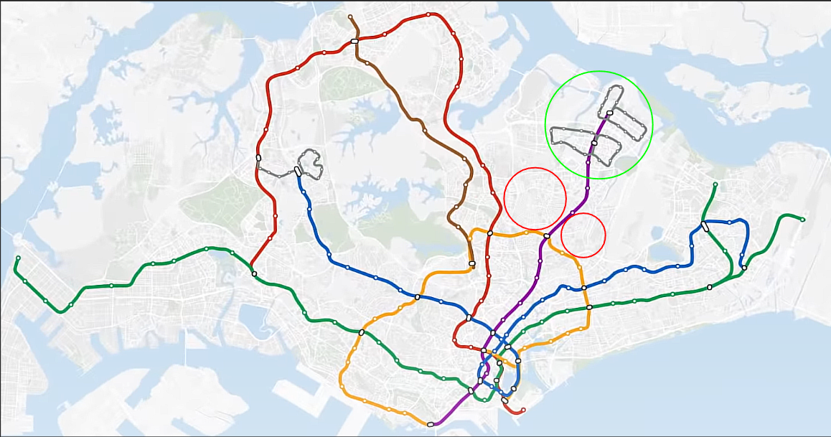

Figure 16: Green circle is ideal coverage, red is poor coverage

For instance, the red circles in Figure 16 near Serangoon station (yellow and purple line intersection), one of the towns outlined earlier, has sparse coverage of the MRT system compared to the green circle which is the Punggol region where the R-square is below 0.3 (blue) in Figure 15 and can be largely explained by the evenly spread LRT network.

### School & Mall Proximity

We took a similar approach analysing the explained variation of school distance and mall distance with resale price. Again, the relationship was contrary to what we expected.

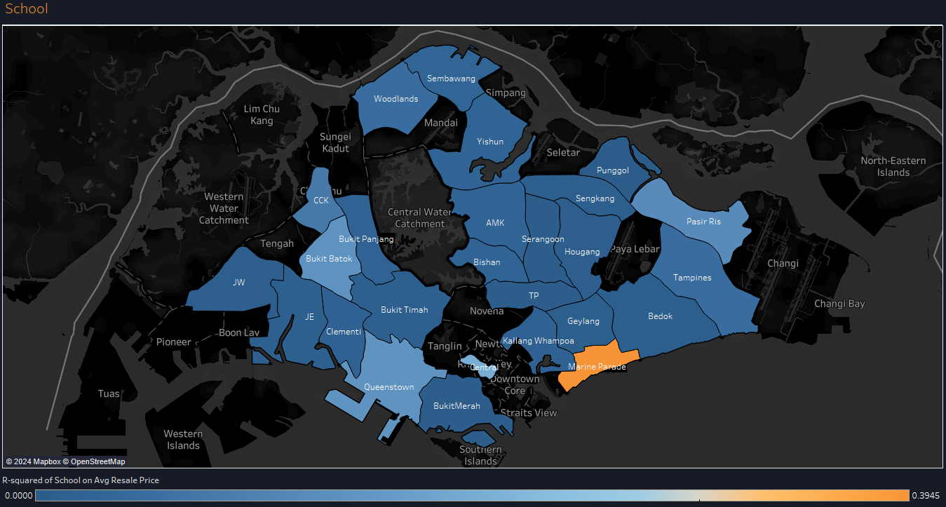

Figure 17: School Distance and explained variation on Avg Resale Price (Centre = 0.3)

School distance was not found to be a significant driver of resale price with only 1 town having a mild R-squared of 0.39, Marine Parade. Due to the weak value of this relationship, we do not have any recommendations.

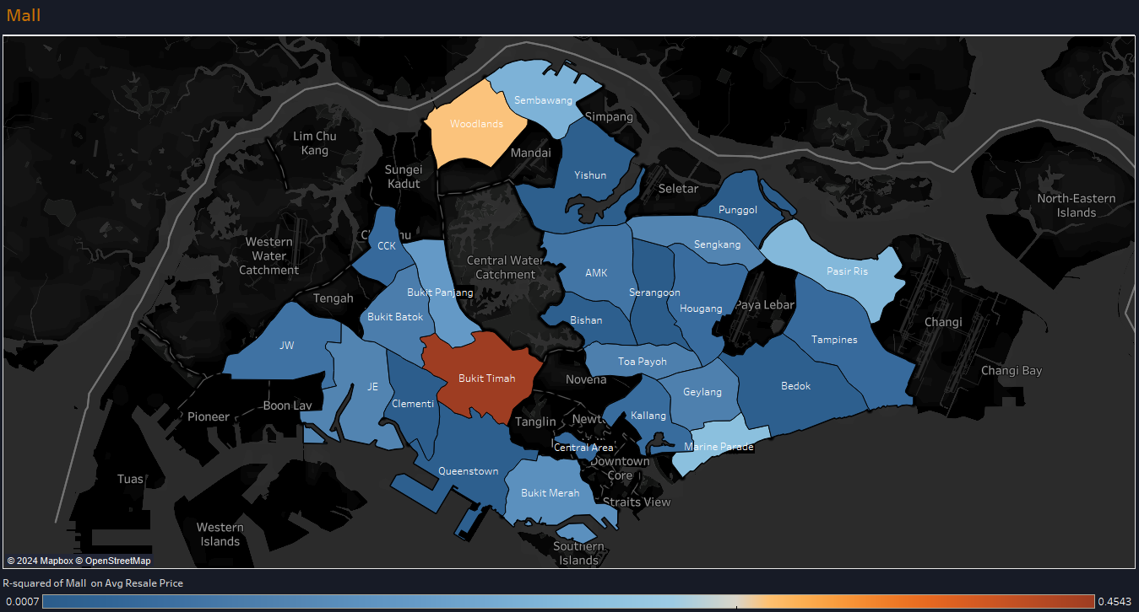

Figure 18: R-squared for mall distance on Avg Resale Price

Replicating our analysis for distance from the nearest mall, R-square was fairly weak across the entire map, with only ‘Bukit Timah’ having a strong correlation of R-squared of 0.45.

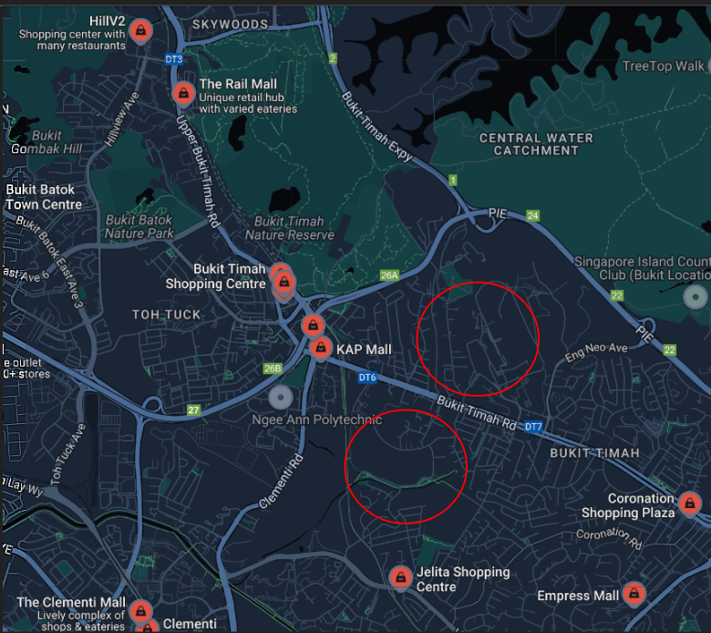

Figure 19: Map view of Malls in Bukit Timah Area

We conducted further research on mall spread in Bukit Timah and find a very focused concentration of malls near the nature reserve with no intermittent malls stretching to coronation plaza on both sides of Bukit Timah Road, likely explaining why Mall distance is a stronger determinant of price in the Bukit Timah Area.

We recommend that further studies be conducted into developing the mall accessibility in the Bukit Timah and Woodlands area, but this falls beyond the scope of our dataset. For example, the Bukit Timah stretch is notorious for heavy traffic, has multiple institutions, and landed properties with the road running alongside a canal, posing considerable engineering challenges. A more prudent approach would be emulating the successful approach of Thomson road, which has shops and eateries lining residential spaces that act as suitable substitutes to an impractical emplacement such as a standalone mall. The presence of multiple downtown line stations along this stretch help facilitate such a plan, with high traffic of people from parents, students and educators alike in the educational institutions. However, this is notably low priority relative to more important findings such as improving coverage for towns with inadequate MRT access outlined earlier.

## Consumer Flat Finder & Price Predictor

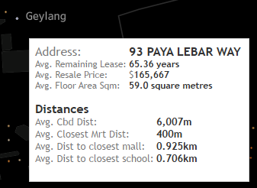

Figure 20: Consumer Dashboard

By entering the various parameters provided in the Flat Finder Dashboard, consumers will be able to search for desirable locations based on their requirement, and get an estimation of various housing information from the tooltip, particularly resale price. They can also compare this with the government dashboard and use the price prediction tool constructed using multiple linear regression (Appendix A) to validate their findings. With this plethora of information, customers would be more well-informed and avoid accepting excessively high flat prices disproportionate to their true worth such as the anomaly outlined earlier in Figure 11.

# Conclusion & Future Work

## Conclusion

As a whole, our spatial and temporal analysis of HDB resale prices in Singapore indicate that decreasing affordability of flats is expected across Singapore. The main drivers of resale price such as interest rate, lease remaining and floor square area are not easily amended, mandating a focus towards public infrastructure. In our analysis we found that MRT coverage was a strong driver of resale price relative to school and malls. Hence, focusing efforts into improving MRT/LRT coverage in the towns mentioned under 8.3 MRT analysis will help increase the supply of desirable flats, decentralising demand and reduce the premium of flats closer to stations, thereby improving affordability. A strong model of successful application would be the Punggol district and its LRT network.

**Architecture and development directions**

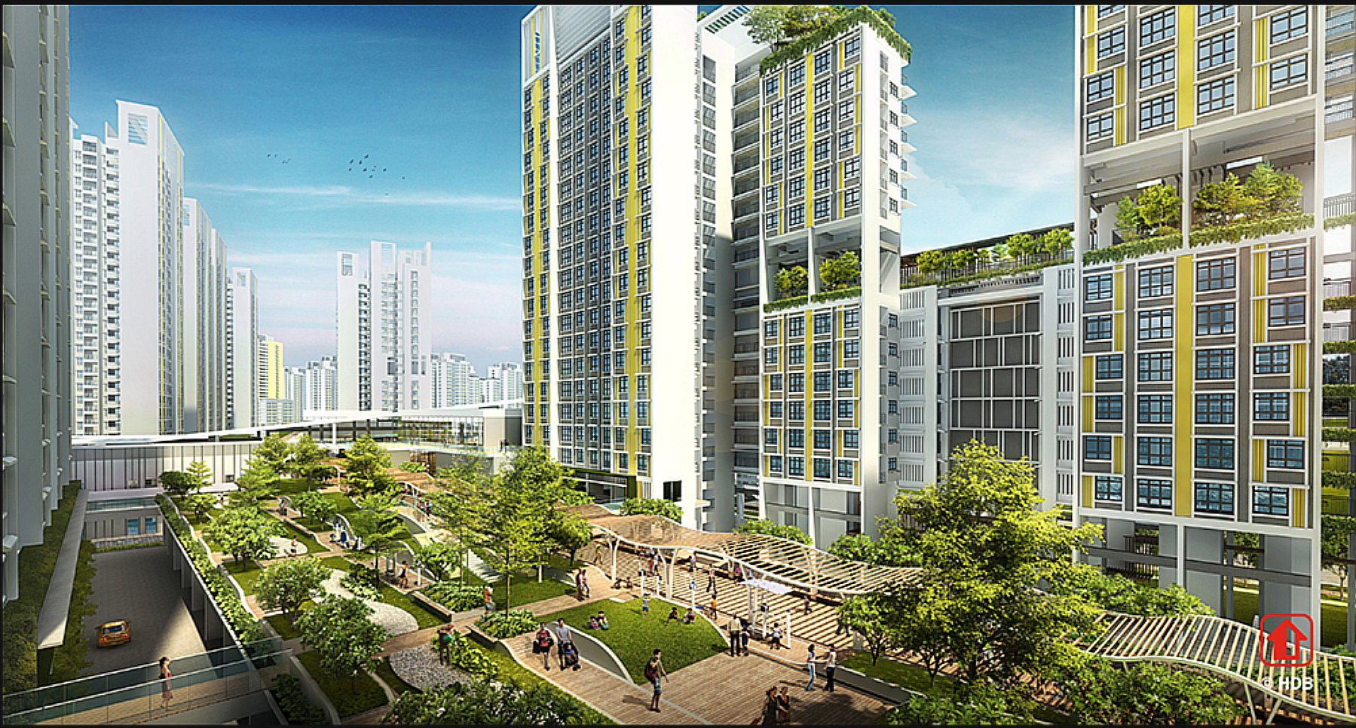

Figure 21: Punggol Northshore

Additionally, we found that flats above the 15th floor fetch a higher premium due to soft factors such as less pest infestations and less noise, more privacy, and treetops view. A longer-term architectural solution will be to integrate equitable man-made green spaces to improve the aesthetics on lower levels and distribute access regardless of flat level. Figure 21 is an actualised concept of the Punggol Northshore district, featuring a design where green spaces are an integral element of living regardless of the floor. Going even further, new estates can integrate shops or lifestyle spaces at the lowest levels of an apartment building such that living space is only above the 3rd floor. A sheltered rooftop garden can also provide shared green spaces and views normally exclusive to the highest floors for all residents, enhancing the natural feel and view regardless of unit storey level and purchasing power of tenants.

## Current Limitations & Future Work

Due to the project time constraints, we were unable to consider a combination of qualitative and quantitative aspects of public infrastructure simultaneously in how they influence resale price. For example, the MRT network has some key transport nodes such as the circle line interchanges or interchange stations like Dhoby Ghaut with up to 3 lines intersecting. The proximity to these stations grant more accessibility around the island.

Additionally, we did not consider the effect of the bus network and interchanges on resale price, which is also a crucial part of public transport infrastructure. For school analysis, we could have considered focussing on proximity to nearest primary school specifically, as parents would generally give more weight to considering the distance from their young children while they are at school, as compared to, for example, the distance from young teenagers in secondary school.

Another limitation is that our Tableau Dashboards rely on static data, which is difficult to compile from multiple sources. Within this time-frame, we were unable to source for an automated API call to multiple datasets containing all our desired information. Other valuable factors such as exact interest rate of each transaction, racial quotas, and traffic volume along the MRT lines and bus routes (Appendix B) were not available or could not be integrated in time. We also could not consider soft factors such as ambient temperature, noise and sun direction into our analysis.

The next limitation is that the calculated distances from each resale unit to the nearest school or MRT is straight line distance. The calculated distances are inherently shorter than the actual distances because of route paths and obstacles. A plausible solution to this is to use Google Maps API for pathfinding. However, this would also entail making over 800,000 API calls to generate this column.

With a more detailed HDB resale dataset, time, and a quantitative and qualitative analysis of both MRT and bus networks, we might have been able to come up with more informed data-driven solutions to preserve the affordability of public housing in Singapore.

# References

* Chong, X. W. (2024, Oct 2). Singapore public housing rated as highly attainable, affordable: reports. The Business Times. <https://www.businesstimes.com.sg/property/singapore-public-housing-rated-highly-attainable-affordable-reports>
* Foo, S. T. (2021, June 8). Commentary: Is housing still affordable for first-time homeowners?. CNA.<https://www.channelnewsasia.com/commentary/bto-hdb-expensive-city-center-young-couples-first-home-1841541>
* Loh, V. W. K., Lim, Z. E., Tan, L. (n.d.).HDB Prices Across Different Towns in Singapore. [Tableau. https://public.tableau.com/views/HDBPricesAcrossDifferentTownsinSingapore/Viz?%3Aembed=y&%3AshowVizHome=no&%3Adisplay_count=y&%3Adisplay_static_image=y](https://public.tableau.com/views/HDBPricesAcrossDifferentTownsinSingapore/Viz?%3Aembed=y&%3AshowVizHome=no&%3Adisplay_count=y&%3Adisplay_static_image=y)
* HDBestimate. (n.d.). HDBestimate.<https://hdb-estimate.herokuapp.com/>
* Housing & Development Board. (2024, May 12). HDB | New Resale Flat listing service enables HDB flat owners to list & market their flat on the HDB flat portal. Housing & Development Board.<https://www.hdb.gov.sg/cs/infoweb/about-us/newsand-publications/press-releases/12052024-NewResale-Flat-Listing-Service>
* OECD. (n.d.) Housing prices. OECD. <https://www.oecd.org/en/data/indicators/housing-prices.html>
* J, R. (2022, September 12). Unaffordable homes in Singapore are causing the younger generation to rent: Is this a good idea?. Property Blog Singapore - Stacked Homes. <https://stackedhomes.com/editorial/unaffordable-homes-in-singapore-are-causing-the-younger-generation-to-rent-is-this-a-good-idea/#gs.ek4t00>
* Jewel, S. (2023, September 16). 56% young Singaporeans worried they couldn’t afford a home: OCBC Survey Singapore News. The Independent Singapore News.<https://theindependent.sg/56-young-singaporeans-worried-they-couldnt-afford-a-home-ocbc-survey/>
* Urban Redevelopment Authority (n.d.).Master Plan. Urban Redevelopment Authority <https://www.ura.gov.sg/Corporate/Planning/MasterPlan>
* Ohmyhome. (2024, April 3). A step-by-step guide to buy HDB resale flat in 2024. Ohmyhome.<https://ohmyhome.com/en-sg/blog/timeline-buyinghdb-resale-flat-hdb-resaleprocedure/?kw=&cpn=20585486562&utm_term=&utm_campaign=Pmax%2B%28Property%2BSeller%29&utm_source=adwords&utm_medium=ppc&hsa_acc=3924092188&hsa_cam=20585486562&hsa_grp=&hsa_ad=&hsa_src=x&hsa_tgt=&hsa_kw=&hsa_mt=&hsa_net=adwords&hsa_ver=3&gad_source=1&gclid=CjwKCAjw6JS3BhBAEiwAO9waF4hx7Qstg4SqfRu01lp1FA3kntlRWfUe7_erR2Dhtc1XMHmFAXKQthoCm2UQAvD_BwE>
* Rapacki, K. (2023, September 26). The public housing paradox in Singapore. The Architectural Review.<https://www.architectural-review.com/essays/the-public-housing-paradox-in-singapore>
* Singapore property and real estate for Sale & for Rent. Singapore Property and Real Estate for Sale & for Rent. (n.d.). [99.co. https://www.99.co/](https://www.99.co/)
* Stevens, H. (2024, April 13). The growing contradictions of Singapore’s HDB scheme. New Mandala.<https://www.newmandala.org/singapores-hdb-cbh/>
* Taufiq, Z. (2023, November 17). The big read in short: The hard truths and trade-offs of homeownership in Singapore. TODAY.<https://www.todayonline.com/big-read/bigread-short-hard-truths-and-trade-offshomeownership-singapore-2307666>
* Tien Foo, S. (2024, May 29). The Three-level Problem With Fake $2 Million HDB Flat Listings. Bizbeat..<https://bizbeat.nus.edu.sg/thoughtleadership/article/the-three-level-problem-with-fake2-million-hdb-flat-listings/>

# Appendix A

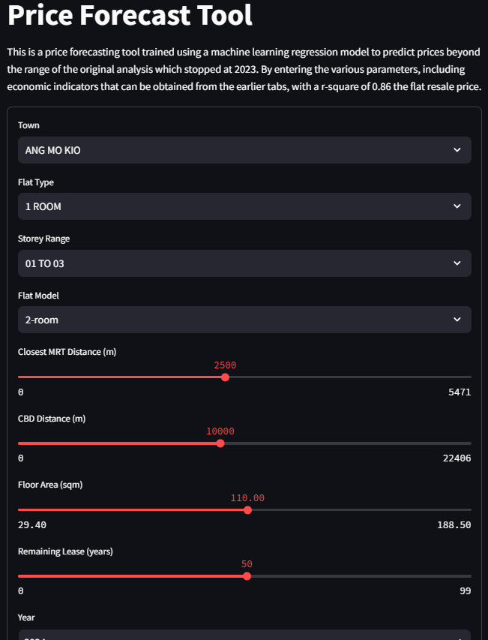

Figure 22: [Price Forecast Tool on the website made using a linear regression model](https://is428-proj.streamlit.app/Price_Forecast_Tool)

# Appendix B

[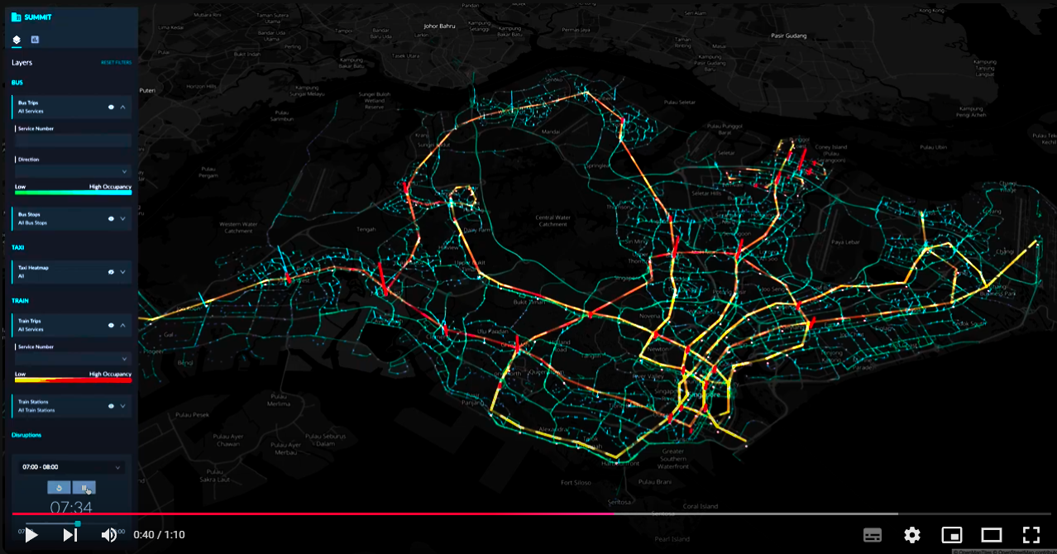](https://www.youtube.com/watch?v=5ABGL8h7fU4&t=40s)

Figure 23: [Visualisation of Public Transport travel demand](https://www.youtube.com/watch?v=5ABGL8h7fU4&t=40s)